will discuss the different **bootstrap button classes** and their use   
  
  
  
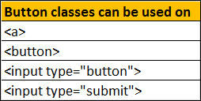  
  
Notice on the following elements we are not using any bootstrap classes.

<button>Button</button>

<input type="button" value="Input">

<input type="submit" value="Submit">

By default the above elements will be styled as shown below.   
Bootstrap button classes  
  
Adding **btn** class applies bootstrap styles to the button and input elements.

<button class="btn">Button</button>

<input class="btn" type="button" value="Input">

<input class="btn" type="submit" value="Submit">

**Output :**   
bootstrap button styles  
  
**Bootstrap button classes** : Along with the **btn** class, one of the following button classes can be used. The colour scheme you get depends on the class you use.   
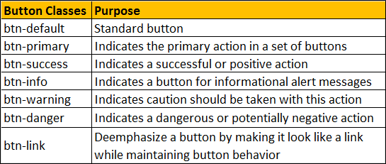  
  
**Example :** To get the buttons lined up one below the other instead of being side-by-side, I have placed them inside a <p> element.

<p><button class="btn btn-default">btn-default</button></p>

<p><button class="btn btn-primary">btn-primary</button></p>

<p><button class="btn btn-success">btn-success</button></p>

<p><button class="btn btn-info">btn-info</button></p>

<p><button class="btn btn-warning">btn-warning</button></p>

<p><button class="btn btn-danger">btn-danger</button></p>

<p><button class="btn btn-link">btn-link</button></p>

**Output :**   
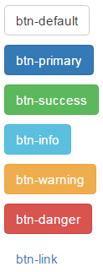  
  
**To make an anchor element look like a button**, use **btn** class along with the other button classes (like btn-default, btn-primary etc.)

<a href="#" class="btn btn-primary">Hyperlink</a>

**Output :**   
bootstrap hyperlink button  
  
**Changing Button Size :** Use the following button classes to get large, small or extra small buttons   
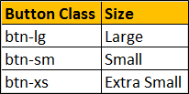

<button class="btn btn-primary btn-lg">Large</button>

<button class="btn btn-primary btn-sm">Small</button>

<button class="btn btn-primary btn-xs">Extra Small</button>

**Output :**   
bootstrap 3 buttons size  
  
To create a button that span the full width of it's parent use **btn-block** class  
  
**Example :** The following example displays   
All the 4 buttons side by side in a single line on a large screen  
3 buttons side by side in the first line and the last button in the second line on a medium screen  
2 buttons side by side in the first line and the rest 2 buttons side by side in the second line on a small screen  
All the 4 buttons one below the other on an extra small screen  
  
What this example the button width is fixed

<div class="container">

    <div class="row">

        <div class="col-lg-3 col-md-4 col-sm-6 col-xs-12">

            <div class="customDiv">

                <button class="btn btn-primary">Button 1</button>

            </div>

        </div>

        <div class="col-lg-3 col-md-4 col-sm-6 col-xs-12">

            <div class="customDiv">

                <button class="btn btn-primary">Button 2</button>

            </div>

        </div>

        <div class="col-lg-3 col-md-4 col-sm-6 col-xs-12">

            <div class="customDiv">

                <button class="btn btn-primary">Button 3</button>

            </div>

        </div>

        <div class="col-lg-3 col-md-4 col-sm-6 col-xs-12">

            <div class="customDiv">

                <button class="btn btn-primary">Button 4</button>

            </div>

        </div>

    </div>

</div>

**Here is customDiv class**

.customDiv{

    padding:10px;

    width:100%;

}

We want the button width to span the full width of it's parent grid column. This can be very easily achieved by applying btn-blcok class on all the button elements.

<div class="container">

    <div class="row">

        <div class="col-lg-3 col-md-4 col-sm-6 col-xs-12">

            <div class="customDiv">

                <button class="btn btn-primary btn-block">Button 1</button>

            </div>

        </div>

        <div class="col-lg-3 col-md-4 col-sm-6 col-xs-12">

            <div class="customDiv">

                <button class="btn btn-primary btn-block">Button 2</button>

            </div>

        </div>

        <div class="col-lg-3 col-md-4 col-sm-6 col-xs-12">

            <div class="customDiv">

                <button class="btn btn-primary btn-block">Button 3</button>

            </div>

        </div>

        <div class="col-lg-3 col-md-4 col-sm-6 col-xs-12">

            <div class="customDiv">

                <button class="btn btn-primary btn-block">Button 4</button>

            </div>

        </div>

    </div>

</div>

To disable a button set disabled attribute to disabled

<button class="btn btn-primary" disabled="disabled">Disabled Button</button>

**Output :** When you move the mouse over the disabled button, the cursor style changes to a stop sign, indicating that the button cannot be clicked.   
bootstrap disable button  
  
To disable an anchor element use disabled class

<a href="#" class="btn btn-primary disabled">Hyperlink</a>

bootstrap disable hyperlink